1. Write a query for in a day how many vender, employee, recruiter and candidates login into a system.(Use 128 talic)

**Count of Login History**

Query:

SELECT COUNT(*)

FROM login_history lh

WHERE lh.LOGIN_DTTM

BETWEEN '2023-02-01 00:00:00' AND '2023-02-06 23:59:59'

AND lh.COMPANY_MSTR_SEQ = 128

OR lh.COMPANY_MSTR_SEQ = 146;

Output:

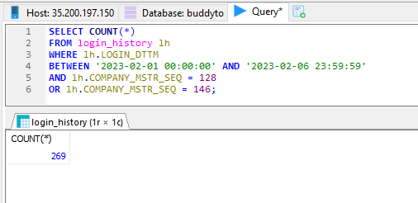

**Daily Login of various User Roles**

Query:

SELECT up.USER_ID,up.LAST_LOGIN_TS,ur.USER_ROLE_DESC,lh.LOGIN_DTTM,lh.LOGOUT_DTTM,ur.USER_ROLE_CD, COUNT(ur.USER_ROLE_CD)

FROM user_profile up

JOIN user_role ur ON up.USER_ROLE_SEQ=ur.USER_ROLE_SEQ

JOIN login_history lh ON up.USER_PROFILE_SEQ = lh.USER_PROFILE_SEQ group by ur.USER_ROLE_CD having lh.LOGIN_DTTM<='2023-02-06 18:00:00'

Output:

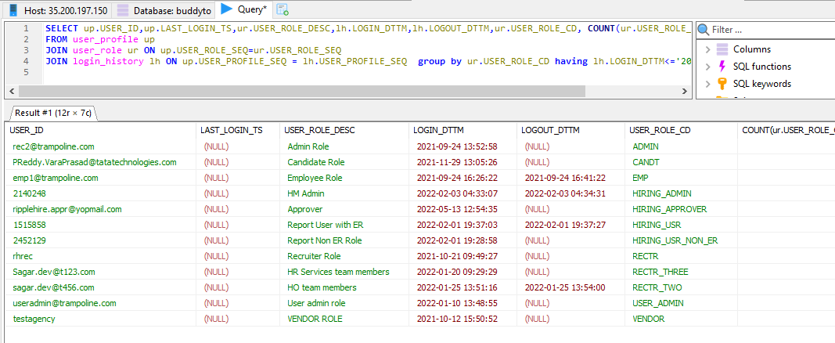

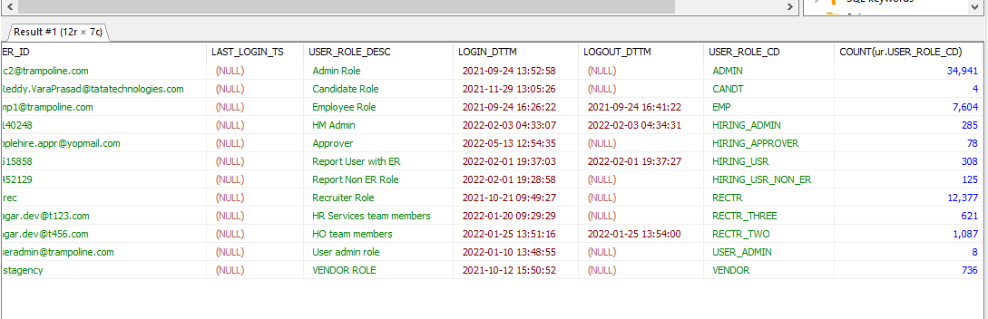

2. Give a count of inactive users and active users to their previous active count.

Query:

SELECT us.USER_STATUS_CD,up.USER_ID, COUNT(us.USER_STATUS_CD)

FROM user_profile up, user_status us WHERE up.USER_STATUS_SEQ=us.USER_STATUS_SEQ GROUP BY us.USER_STATUS_CD;

Output:

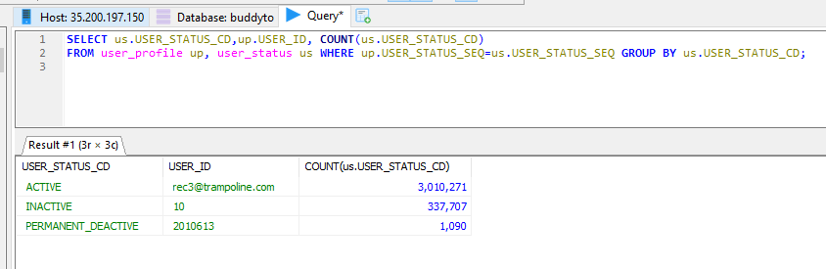

3. How can I change a recruiter to an admin user?

Query:

Output:

4. How can I change an employee to an admin user?

Query:

Output:

5. Give a count and identify various system roles ?

Query:

SELECT User_role_cd, COUNT(user_role_cd)

FROM user_role

GROUP BY USER_ROLE_CD;

Output:

